**Introduction:** This budget management data is solution is describing about the monthly money flow control. In which we are making a track of every month income, expanses, investment and savings for the future.

Supposes someone earning monthly income from the different-different resources such as job, business, home rent etc. from which person generating his monthly income and expanding every month for his daily use and out and if he had taken some investment policy then it is also making a track of that such as which data he had submitted the amount how much amount he had submitted etc. and it also makes a record of his monthly saving based on that a person can make his retirement plan.

**Detailed Analysis of the database:**

In this analysis, we are going to discuss about tables and forms and report which we are using in the database.

**Monthly Income:** This table is collecting the information about income of the person the view of the table is given below. Here ID is the primary key of the table monthly income and Month_ID will be used as the foreign key for the table Month, by which we can insert the records.

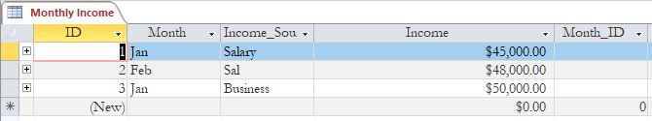

**Monthly Expanses:** This table is collecting the information aobut the monthly expanses of the person.

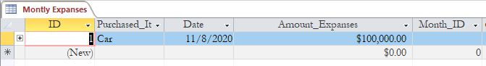

**Investment:** This table is collecting the inforamtion of the person, that if he is investing certain sum of moneny, then we can make a track of that.

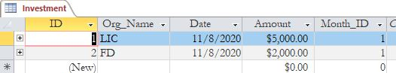

**Monthly Savings:** This tables is collecting and mainting the information related to the monthly saving of the person.

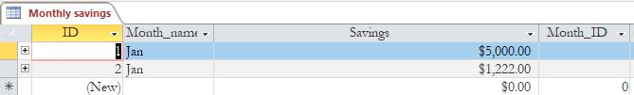

**ER diagram:** The ER diagram of the database is given below-

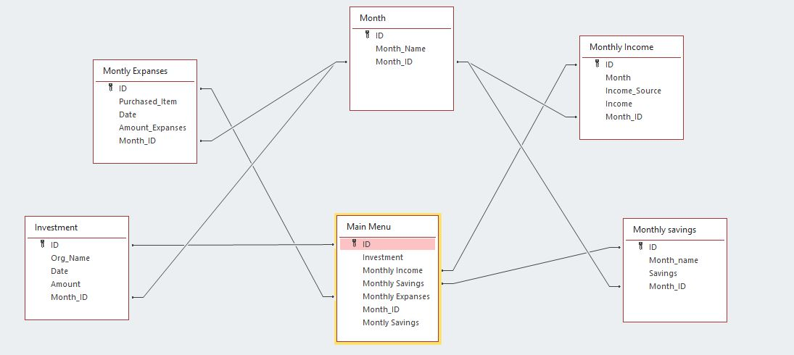

**Form Analysis:**

**Income form:** The given monthly income form is providing the user interface for the insertion of the data for the particular month in which certain fields are given.

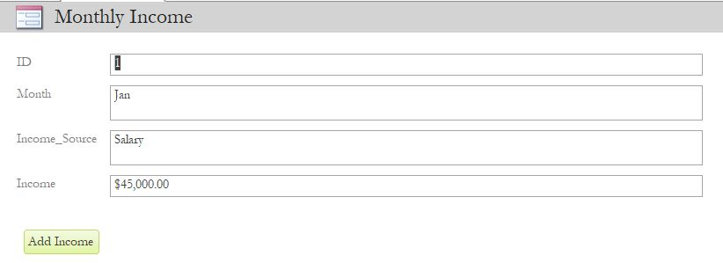

**Monthly Expenses:** This particular user interface is providing the information related to monthly expanses. By which we can insert the records.

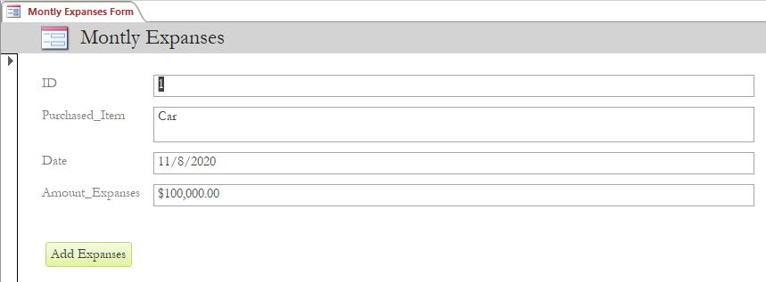

**Investment Form:** This particular user interface is providing the information regarding the investment, by which we can insert the investment records.

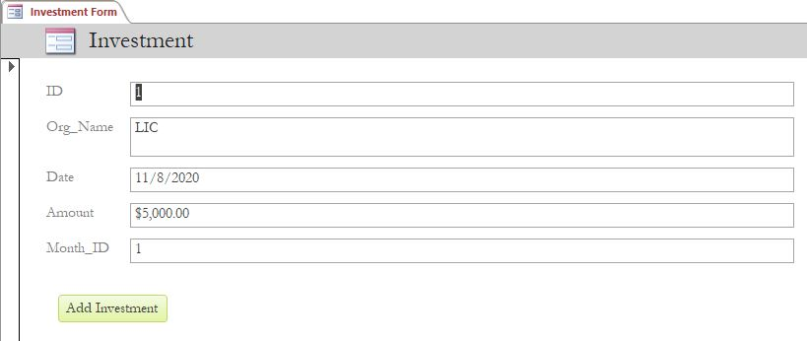

**Monthly Savings:** This particular user inter interface is providing the information about the monthly income.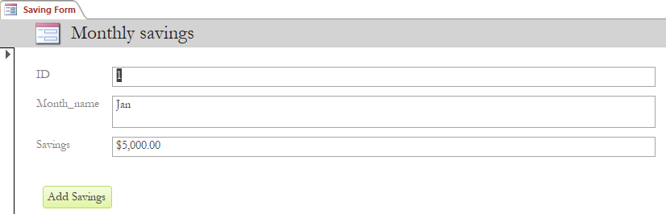

**Monthly Savings:** This particular user interface is providing the information about the monthly savings of the person.

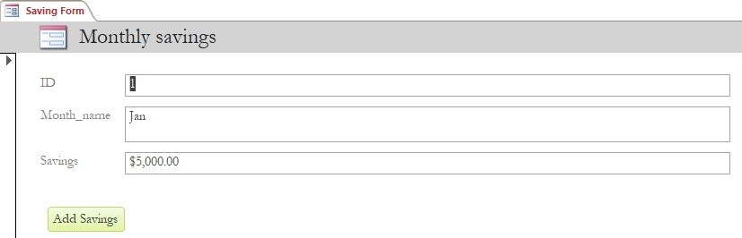

**Main Menu Query:** This particular user interface is providing the information about the overview of the records.

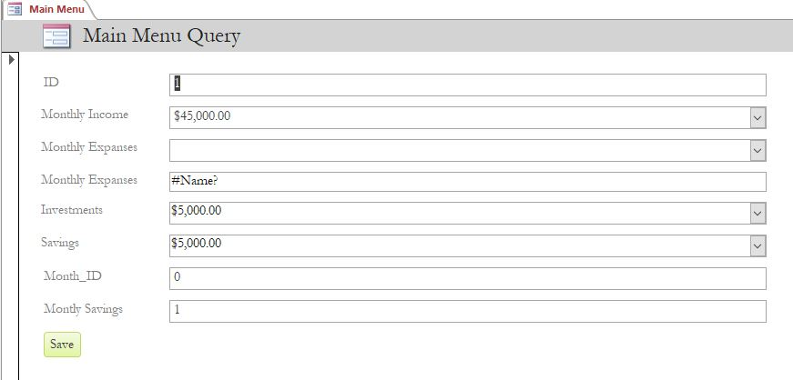

**Budget Management:** This user interface is providing the quick access of the user interface by which we can insert a new records in the database, which will redirect to the given form by which we can insert the records in the database table.

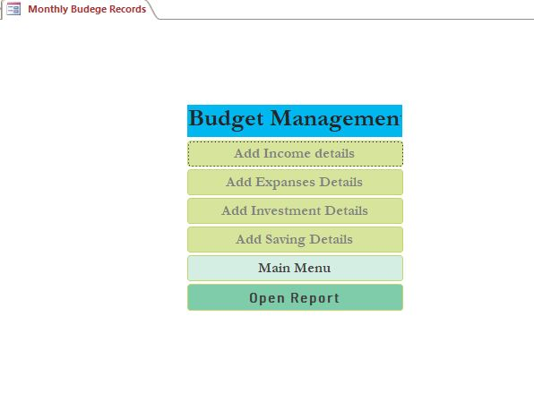

**Conclusion:** This database is making of the track of the flow of the money, and based on the management of the flow of the money we can make the plan for the next investment or the retirement, which can be secure the future requirements.